**Setting up user enabled movement:**

Assign the brain to the Player object in the scene, from the academy.

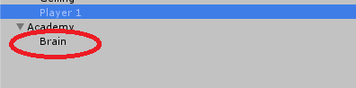

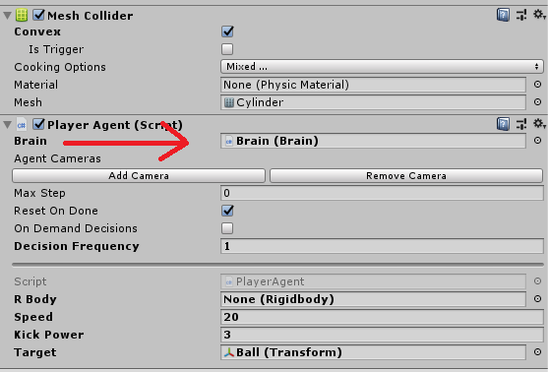

Then by looking at the brain’s properties, assign the brain type to “Player”. This tells the brain that we want to use a player-controlled brain. Below this, assign the Size value in the Key Continuous Player Actions to 4, this tells the brain we want to use four input. We then assign a key to be pressed, an index for this key and a value to determine the direction.

